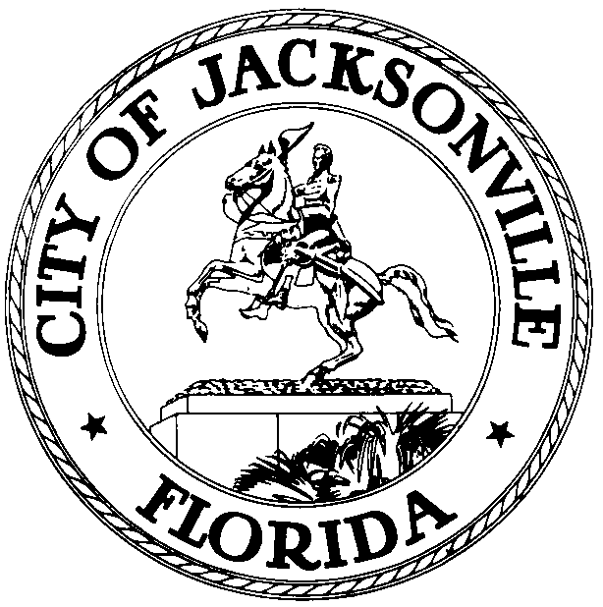

OFFICE OF THE CITY COUNCIL

GREG ANDERSON 117 WEST DUVAL STREET, SUITE 425
2015 – 2016 PRESIDENT 4TH FLOOR, CITY HALL
OFFICE (904) 630-1389 JACKSONVILLE, FLORIDA 32202
FAX (904) 630-2906
E-MAIL: GANDERSON@COJ.NET

July 7, 2014
(12:00 P.M.)

NOTICE

M E M O R A N D U M

TO: City Council Members and Staff

FR: The Honorable Greg Anderson
Jacksonville City Council

RE: 2015 – 2016 Council Agenda and Council Meeting Notification
______________________________________________________________________________
Notice is hereby given that The Honorable Greg Anderson, President, Jacksonville City Council, is hereby calling the Council Agenda Meeting, of the Jacksonville City Council, to be held at 4:00 pm on 2nd and 4th Tuesday of every month. Additionally, the Jacksonville City Council will meet on at 5:00 pm on the 2nd and 4th Tuesday of the month. Council Agenda and Council Meetings will be held in the Council Chamber located at 117 West Duval Street, 1st Floor City Hall – St. James Bldg., Jacksonville, Florida 32202. These meetings will take place at the times listed above unless there is a holiday, upon which the meetings will be pushed back 24 hours.
Please mark your calendars accordingly. All interested parties are invited to attend.
If you have any questions, please contact Legislative Services Division, at (904) 630-1404.

CEY/CLB/df

xc: Council Members/Staff Media Box
Cheryl L. Brown, Director/Council Secretary File Copy
Dana Farris, Chief – Legislative Services Division Mayor’s Office
Carol Owens, Assistant Chief – Legislative Services Division
Jeff Clements, Chief, Research Division
Office of the General Counsel
CITYC@COJ.NET
Electronic Notice Kiosk – 1st Floor City Hall
Public Notice System – City Council Web Page

